Miniproject – 5
Jessica Sriramula
Streamlit deployment guide steps:
To deploy the streamlit application after completion, these are steps to be followed,
Step 1: Go to GitHub and log into your account.
Step 2: Create a new public repository by clicking on the + at the top right hand corner and click on “new repository”, fill in all the details of the new repository such as description, repository name and enable the “add read me” file at the bottom and click on “create repository”.
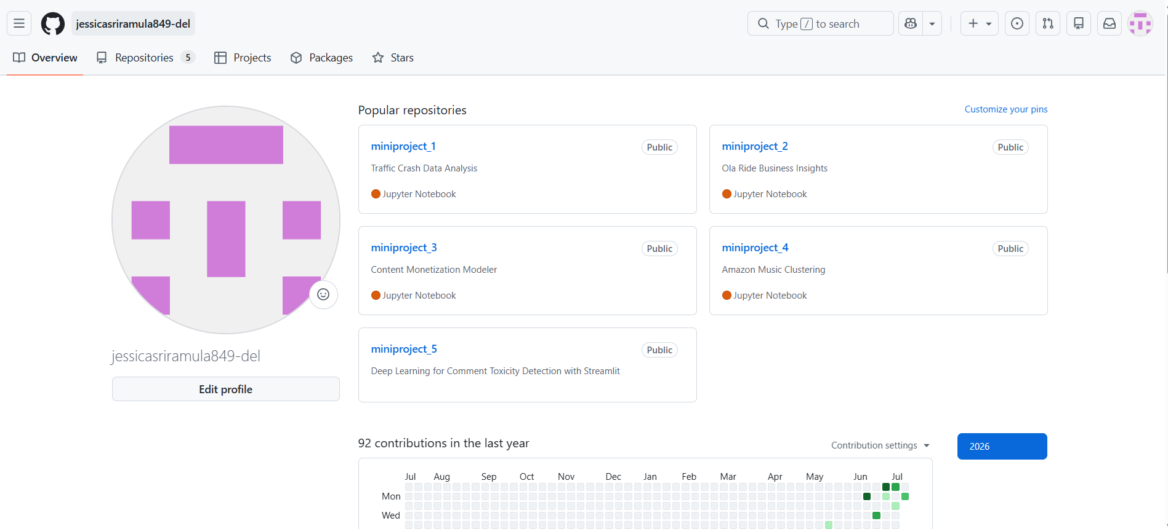
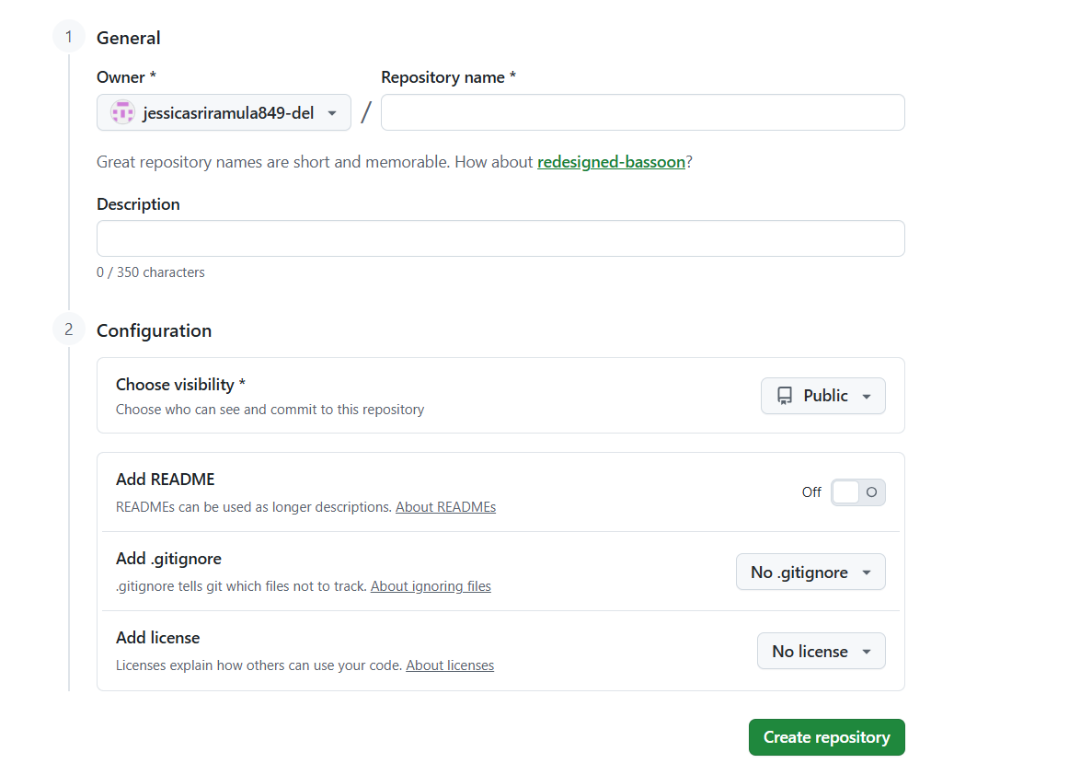

Step 3: Upload or push all your files such as the “py” and “ipynb” files into the main branch of this repository by clicking on “upload file” button after creating the repository in step 2.
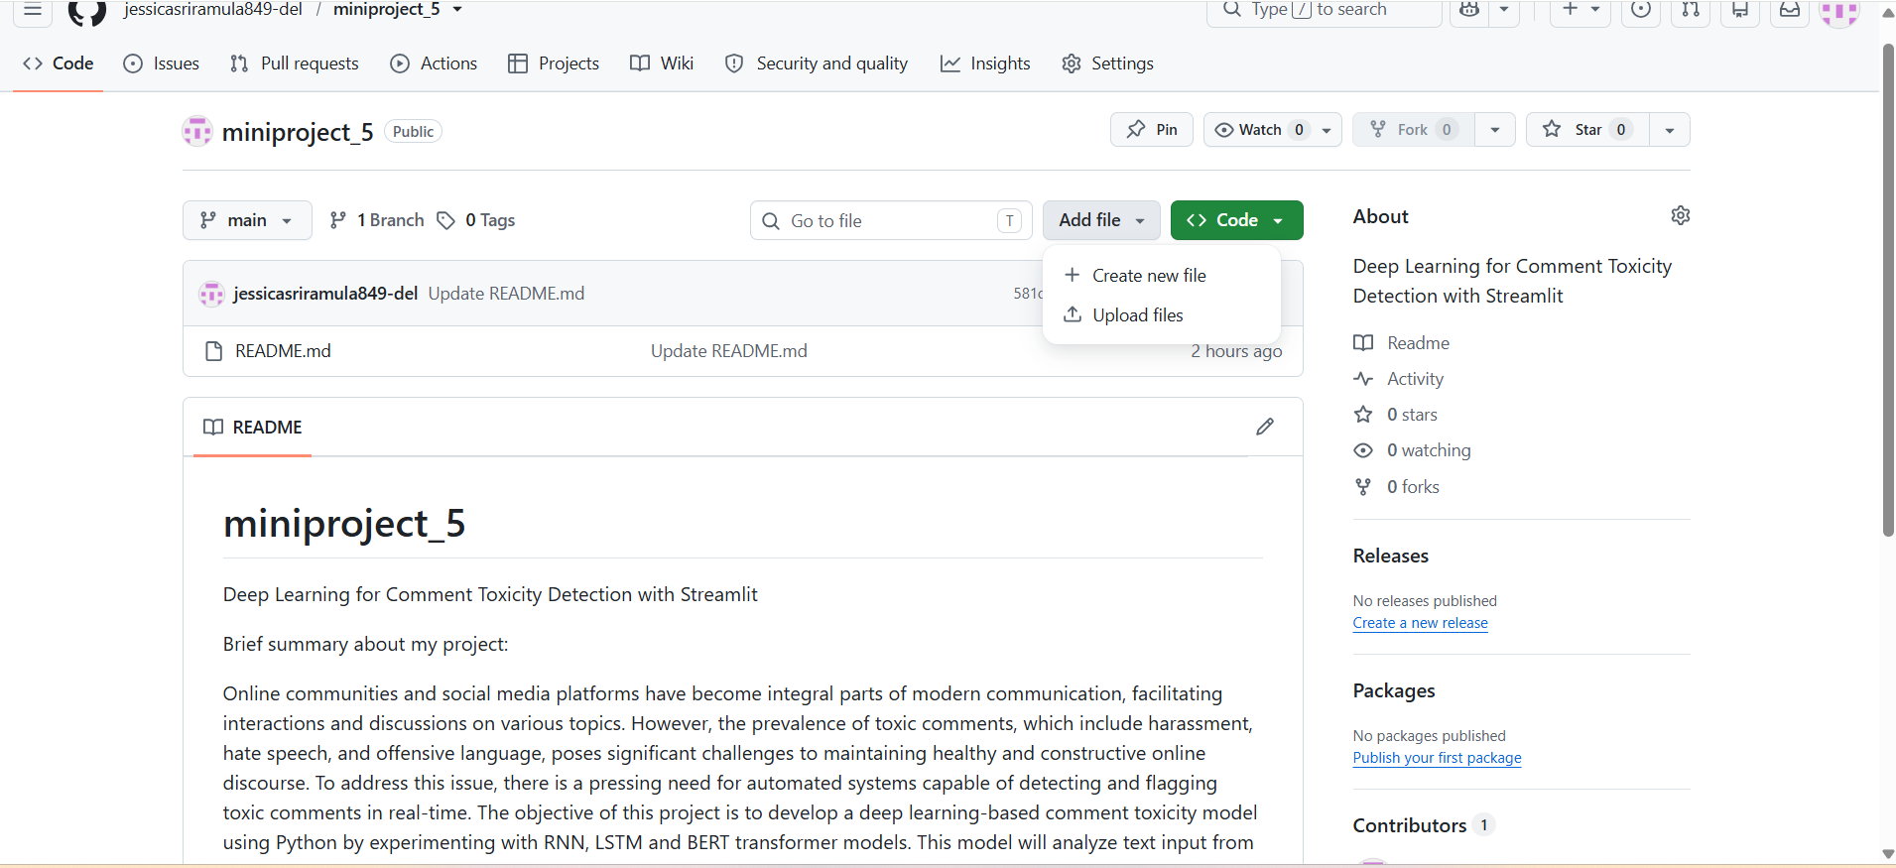

Step 4: Set up a streamlit share account by visiting the Streamlit Community Cloud sign-in page.
Step 5: And login to streamlit using the email and password you setup while setting up the streamlit account in step 4.
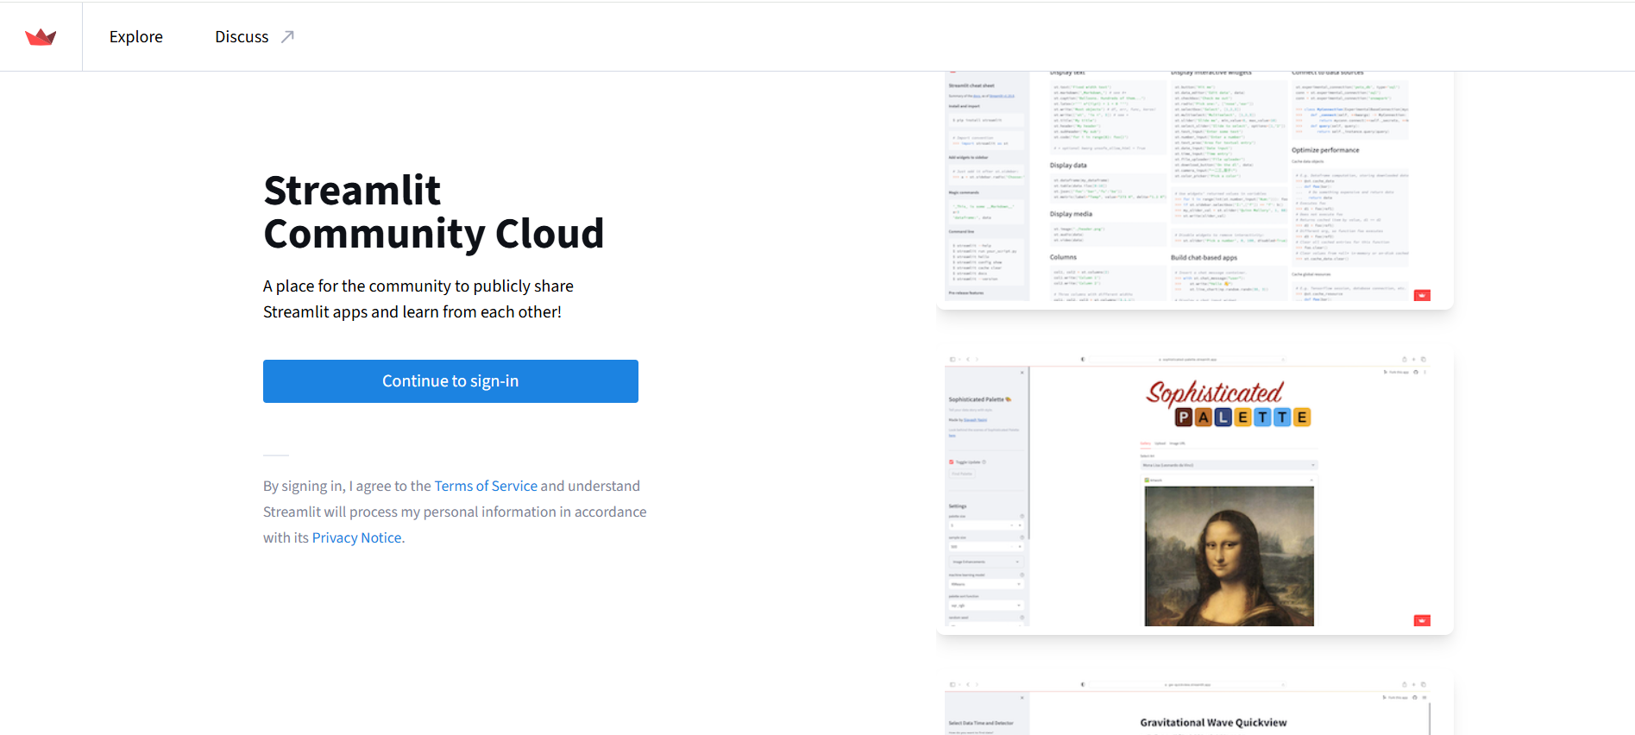

Step 6: Once logged into the streamlit dashboard workspace, click the "Create app" button in the top right corner and then click on “Deploy a public app from github”
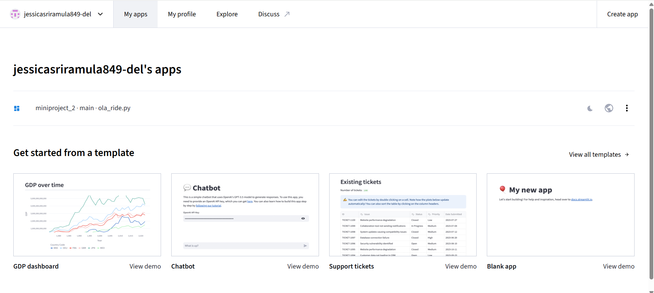

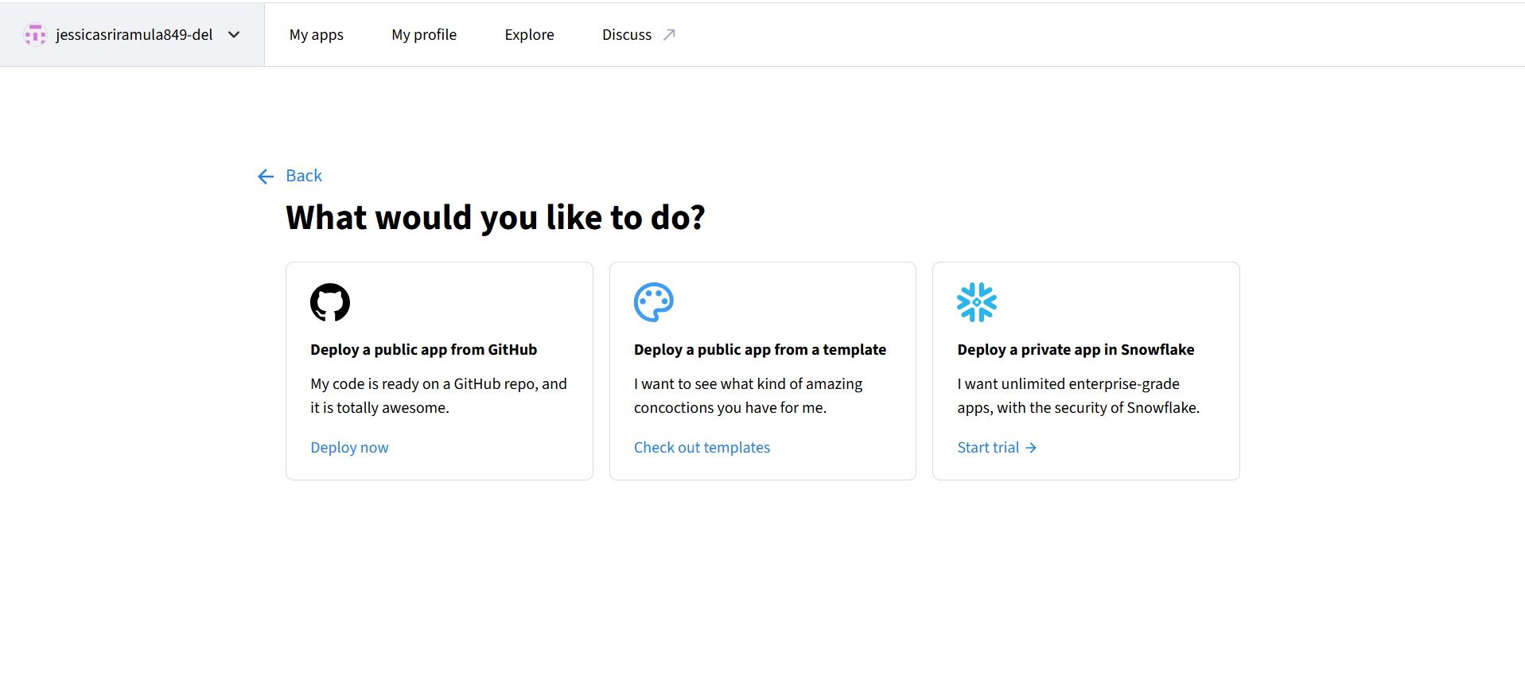

Step 7: Fill out the deployment form fields such as for repository: select your newly created github repository name from the dropdown menu, for branch: select main or master, for main file path: type app.py (or the exact name of your “py” script file as saved in your github repository).
Step 8: Click Deploy!
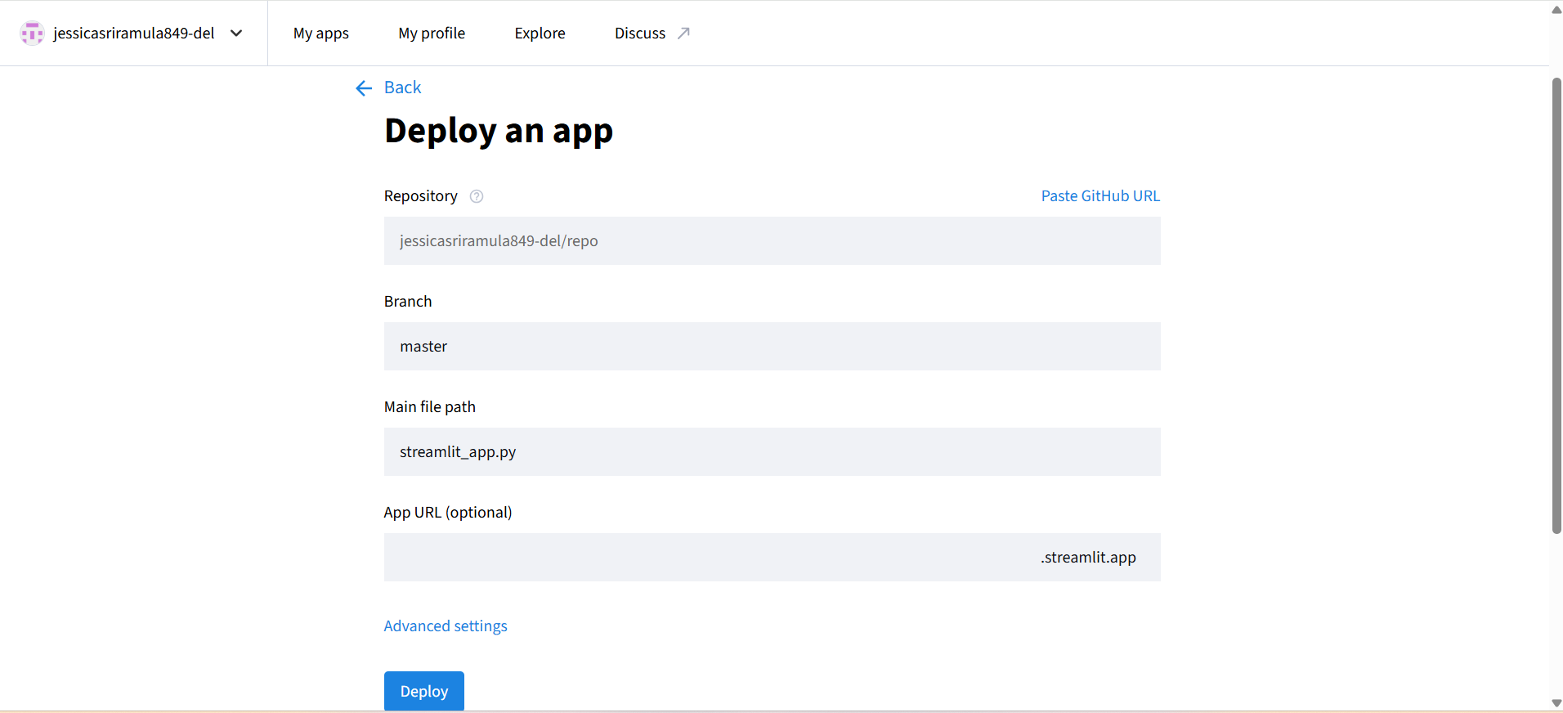

Step 9: Once completed, your application is live! you can copy the unique URL provided in your browser bar to share your real-time toxicity comments detection streamlit application.

